**LAPORAN PRAKTIKUM**

**PEMOGRAMAN BERBASIS OBJECT**

**“Pertemuan ke-11”**



Disusun oleh :

Alifah Fisalsabilawati

201511035

2B – D3 Teknik Informatika

**Jurusan Teknik Komputer dan Informatika**

**Program Studi D3 Teknik Informatika**

**Politeknik Negeri Bandung**

**20.1 – 20.3 Running class Passenger, Flight, Airport.java**

**Hasil output**

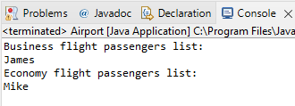

**Passenger.java**

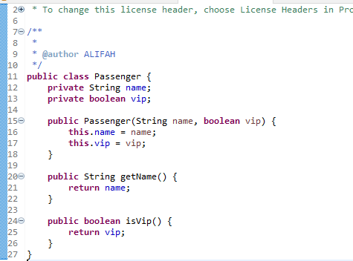

**Flight.java**

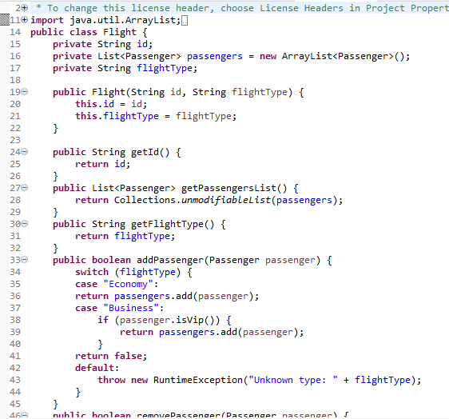

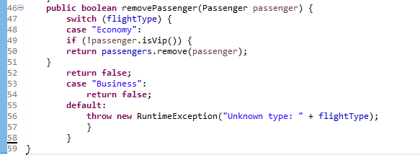

**Airport.java**

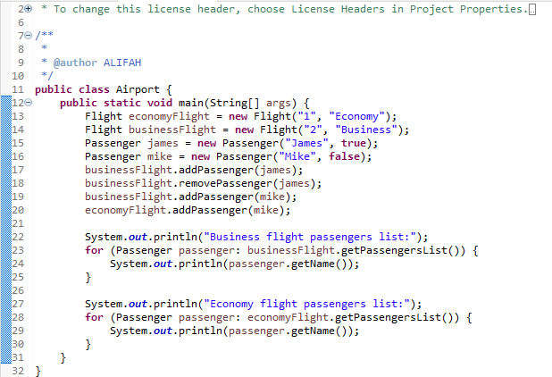

**20.4 Junit 5 depedencies add to pom.xml**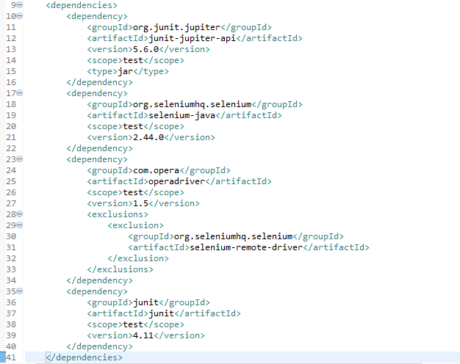

**20.5 testing the business logic for an economic flight**

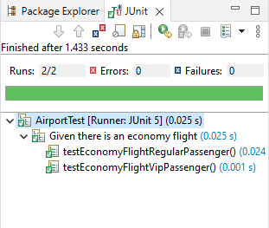

**20.6 testing the business logic for an business flight**

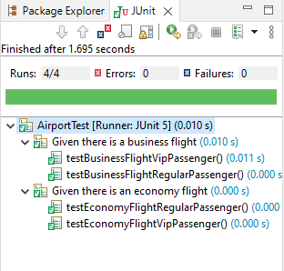

**20.7 Refactoring class flight**

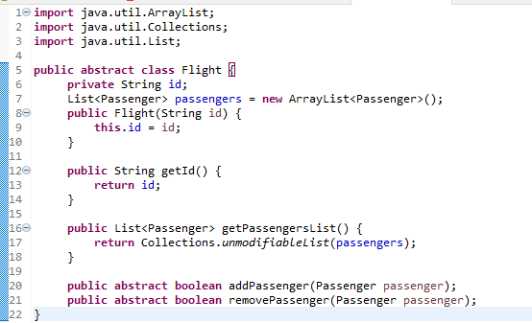

**20.8 – 20.9 membuat economyFlight dan BusinessFlight**

**economyFlight.java**

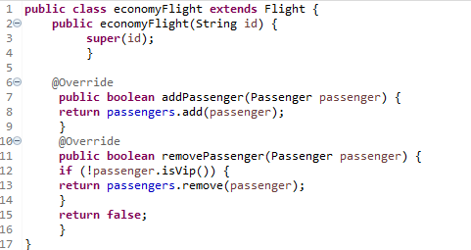

**BusinessFlight.java**

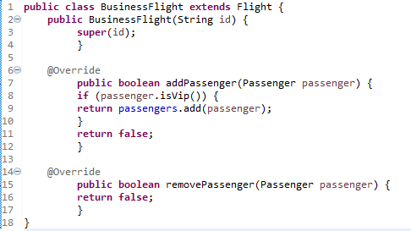

**20.10 Refactoring class AirportTest**

